Judge OKs Facebook Divorce Notice
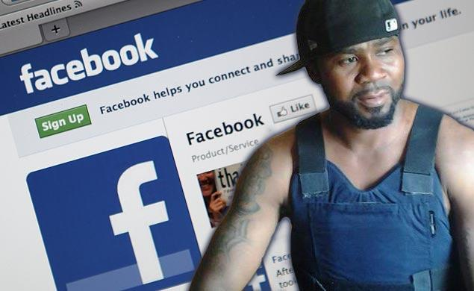
A Manhattan Supreme Court justice has allowed a Brooklyn woman to use Facebook to serve her husband divorce papers. Ellanora Baidoo’s lawyer will message Victor Sena Blood-Dzraku from her account for three weeks, or until he acknowledges her messages. Blood-Dzraku doesn’t have a fixed address and communicates with Baidoo largely by phone and Facebook message.
New York Daily News 4.6.15
http://nydn.us/1MVkjtv

