Justice Dept. Demands for Divestiture Could Delay AT&T Deal
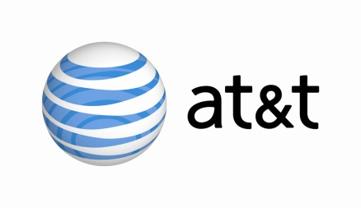
The Justice Department has proposed that AT&T divest DIRECTV or Turner Broadcasting to acquire Time Warner, sources say. AT&T CEO Randall Stephenson has denied reports that the company plans to sell CNN, which is owned by Turner, but Chief Financial Officer John Stephens said that timing for the closing of the deal is now "uncertain."
The Hill 11/8/17
http://thehill.com/policy/technology/359474-justice-att-trade-accusations-over-cnn-sale

