Kraft Shows Support for Real Families in New Branding Push
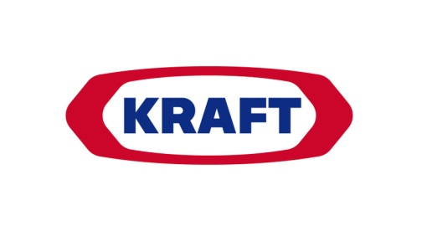
Kraft has unveiled a campaign from Leo Burnett called "Family Greatly," which features real parents and their children to emphasize how the brand "supports today's modern families." The campaign includes new consistent packaging across Kraft brands, TV, digital, a dedicated site and a social effort to encourage families to share their own stories, with the brand's employees also acting as social influencers.
MediaPost Communications 12/12/17
https://www.mediapost.com/publications/article/311484/new-branding-campaign-spans-kraft-products-featur.html

