La. Stations Serve Community During Flooding Disaster
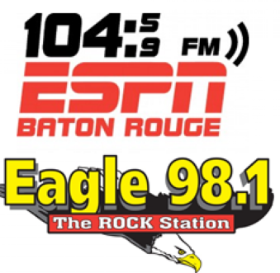
Guaranty Media General's four Louisiana radio stations have been providing around-the-clock coverage and are making plans to help the community recover following flooding that has killed 13 people and damaged at least 40,000 homes. Also, New Orleans NBC affiliate WDSU partnered with Second Harvest Food Bank to raise more than $100,000 for food, water and other supplies for victims.
Radio Ink 8/18/16
http://radioink.com/2016/08/18/radio-rescue-louisiana/

