Label Native Content Clearly, FTC Warns
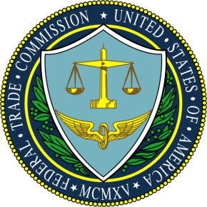
The Federal Trade Commission has announced at an industry conference that it will crack down on publishers regarding native content that is not clearly labeled as advertising. Marking the content as "sponsored" will not be good enough. "An ad is deceptive if it misleads a significant percentage of consumers," said Mary Engle, the FTC's associate director of ad practices.
AdExchanger.com 6/3/15
http://adexchanger.com/publishers/ftc-publishers-will-be-held-responsible-for-misleading-native-ads/

