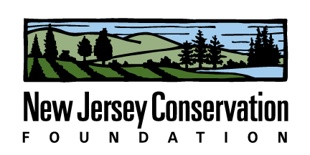

2015 Internship Description

Position Title: Land Conservation Intern

Company Description:
New Jersey Conservation Foundation is a nonprofit organization that preserves open space and farmland throughout New Jersey. We do this by applying land acquisition skills to convince landowners to preserve properties, managing 25,000 acres of land, promoting advocacy and policy issues with state agencies and the state legislature, engaging the public and other conservation organizations in educational activities, and efficiently managing a large conservation nonprofit. To learn more, visit www.njconservation.org.

Job Description: The intern will primarily help the Education and Outreach Director plan workshops for land trusts, manage a grant program and start planning for the statewide conference held in March. The intern will also have an opportunity to engage in all the activities of the organization. The intern will assist in a variety of projects, including field stewardship work, membership recruitment, research for policy initiatives, engaging new partners, planning programs and others. A general knowledge of environmental science is helpful. Interest in marketing, communications, social engagement would also be of use. Position could be full-time or part-time.

Number of openings: 1 per season—Summer; Fall

Desired Majors: Environmental Science, Environmental Studies, Sustainability, biology, ecology, public administration, interest in environmental policy, communications, recreation & parks, others possible

Company Name: New Jersey Conservation Foundation
Company Address: 170 Longview Road, Far Hills, NJ 07931
Company Website: njconservation.org
Contact Name and Title: Laura Szwak, Director, Education & Outreach
Contact Email: Laura@njconservation.org
Contact Phone Number: 908-234-1225 ext. 117

Stipend possible.

