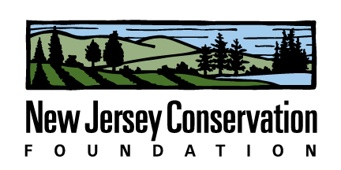

2017 Internship Description

Position Title: Land Conservation Intern

Company Description:
New Jersey Conservation Foundation is a nonprofit organization that preserves open space and farmland throughout New Jersey. We do this by applying land acquisition skills to convince landowners to preserve properties, managing 25,000 acres of land, promoting advocacy and policy issues with state agencies and the state legislature, engaging the public and other conservation organizations in educational activities, and efficiently managing a large conservation nonprofit. To learn more, visit www.njconservation.org.

Job Description: The intern will primarily help with the organization of a statewide conference that will take place on March 17, 2017. Activities include developing the workshop program, communicating with speakers, recruiting exhibitors (including a pop-up farmers market), marketing the event through social media and other forms, all aspects of event planning for a conference that attracts 400 people. The intern will also have opportunities to engage in all the activities of the organization, including field work with the stewardship team, research for the policy team, and event assistance with the development and other activities. A general knowledge of environmental systems is helpful, but not required. Interest in marketing, communications, social engagement, event planning is also useful.

Commitment: Position could be full-time (35 hours/week) or part-time (at least 20 hours/week). Schedule is flexible and developed with the intern’s supervisor. Opportunities to work “virtually” are also possible. Position is open immediately. However, the intern must be able to commit to working from early January through March.

Number of openings: 1-3

Stipend: $1000 for at least a 3-month period

Desired Majors: Environmental Science, Environmental Studies, Sustainability, biology, ecology, public administration, interest in environmental policy, recreation & parks, communications, marketing, others.

Company Name: New Jersey Conservation Foundation
Company Address: 170 Longview Road, Far Hills, NJ 07931
Company Website: njconservation.org
Contact Name and Title: Laura Szwak, Director, Education & Outreach
Contact: Laura Szwak (Laura@njconservation.org; 908-2997-0720)

