New Tech Enhances Worldbuilding For TV, Films
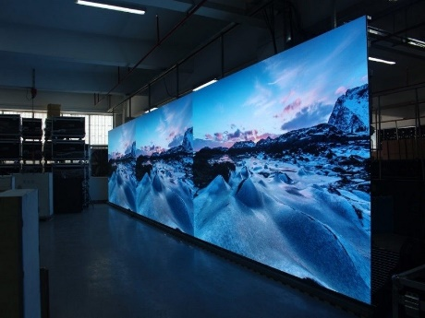
A growing number of television and film productions are embracing new camera and LED wall technology, eliminating the need for travel to different locations and reducing the cost of video effects. Systems designed for video games, which require a number of different settings that may not correspond to real-life places, are becoming part of series such as "The Mandalorian."
TV Tech 11/15/21
https://www.tvtechnology.com/news/new-cameras-led-walls-are-game-changers-for-production
Image credit:
http://www.tecfuturenow.com/media/catalog/product/cache/1/image/1800x/040ec09b1e35df139433887a97daa66f/l/e/led-display-wall-1024x683_1.jpg

