Lessons Learned: McKinsey's Purdue Pharma Missteps
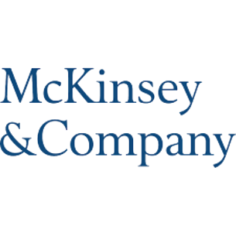
McKinsey's recent $573 million, 47-state settlement regarding their work with Purdue Pharma offers lessons public relations practitioners should heed when working with clients that may be potentially problematic. Reputation Partners' President Nick Kalm offers tips such as write every form of communication as if it could end up on the page of leading newspapers, voice concerns frequently and "be prepared to walk away."
Full Story: PRSAY 2.17.21
http://prsay.prsa.org/2021/02/16/mckinseys-cautionary-tale-for-communicators/

