65% Americans say LGBT-Inclusive Ads Boost Economy
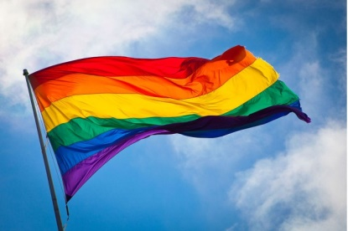
Sixty-five percent of Americans believe that brands that support LGBT communities are good for the economy, but 68% say such support must be backed up evidence that brands are helping the causes they champion, a survey from Ogilvy reports. Forty-eight percent surveyed said they'd boycott brands that were known to discriminate against LGBT communities.
Marketing Dive 6/29/17
http://www.marketingdive.com/news/ogilvy-consumers-value-lgbt-inclusive-brands-but-authenticity-is-key/446126/
Image source:
http://images.thecarconnection.com/med/lgbt-rainbow-flag_100375401_m.jpg

