Big in China: License-Plate Marriages
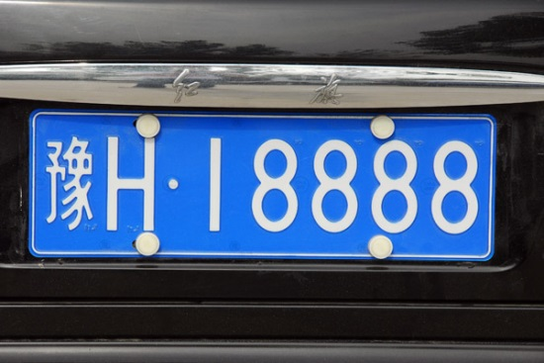
Since any driver who has resided in Beijing for more than a year can register, the drawing is fair in principle. But the license-plate system has a big loophole. While private sales of license plates are banned, the rules allow transfers between spouses. Thus one solution: sham marriages. In crowded forums and chat rooms, plate owners offer to tie the knot—for the right price.
The Atlantic October 2017
https://www.theatlantic.com/magazine/archive/2017/10/license-plate-marriages/537867/?wpmm=1&wpisrc=nl_daily202
Image source:
http://m4.i.pbase.com/o2/93/329493/1/105458574.wSx0RBbp.XianSep08613.jpg

