Lifetime Looks to Spur More Opportunities for Female Creatives
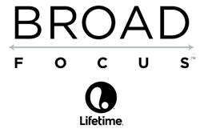
Lifetime is sponsoring a program to push Hollywood to hire more women to develop, write, produce and direct programming. The Broad Focus initiative, for one of its first projects, will air a winning entry from Geena Davis' Bentonville Film Festival and develop one of its winning scripts.
Variety 5/6/15
http://variety.com/2015/artisans/news/broad-focus-women-in-hollywood-jobs-1201488996/

