Like Everything Else, Super Bowl 56 Ads Are Almost Sold Out
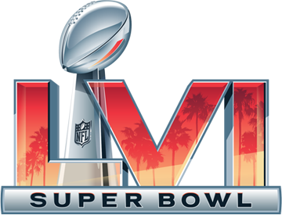
When selling its Super Bowl inventory, NBCUniversal had some considerable leverage when it comes to one of the big audience draws on linear TV and streaming services: live sports. The network offered Big Game slots as part of a Once in a Lifetime sports package.
Advertising Age 10.28.21
https://www.adweek.com/brand-marketing/super-bowl-2022-ads-sold-out-nbc-sports-bonanza/?utm_content=summary_component&utm_source=postup&utm_medium=email&utm_campaign=FirstThingsFirst_Newsletter_211028054610&lyt_id=1418028

