Linear's Dead? Well, It's Still (Slightly) More Efficient Than Netflix
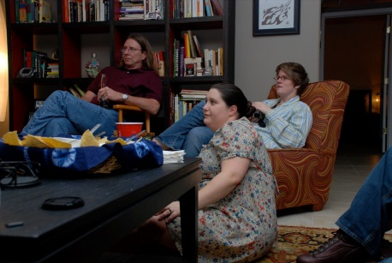
Research company MoffettNathson's report "Media Content Spend Post-Streaming Wars" elegantly showcased how the major media conglomerates were decelerating content spend in order to curb DTC losses.
Next TV 3/24/23
https://www.nexttv.com/news/linears-dead-well-its-still-slightly-more-efficient-than-netflix-chart-of-the-week?utm_term=A25693A1-51B6-4112-BDE4-56BD420E983F&utm_campaign=C74FC4FA-5D4D-4151-8915-3043BA411DBE&utm_medium=email&utm_content=B52C1E28-D1F1-4994-B888-62A36D794E19&utm_source=SmartBrief
Image credit:
https://www.flickr.com/photos/airojade/412234358/

