LinkedIn Enables Company-Specific Ad Targeting
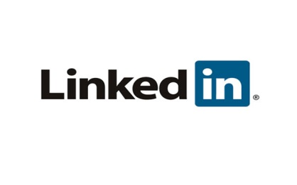
LinkedIn Account Targeting now lets advertisers using Sponsored Updates or Sponsored InMail target up to 30,000 relevant companies in a campaign. It's the first time the platform has allowed marketers to merge their own data into campaigns. "I would say this is slowly opening up the walled garden -- with more to come," said Lindsey Edwards of LinkedIn Marketing Solutions.
Adweek 3/1/16
http://www.adweek.com/news/technology/linkedin-now-allowing-marketers-target-ads-specific-companies-169936

