Lionsgate, Univision to Launch Spanish-Language Streaming Service
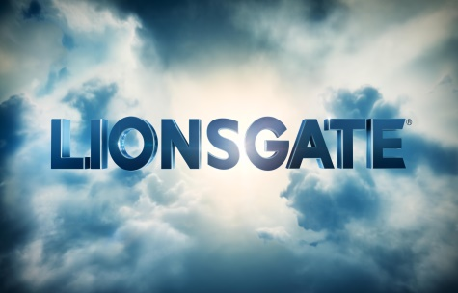
Lionsgate and Univision have teamed up to create a Spanish-language movie-streaming service aimed at Hispanic viewers in the US. The service, which is expected to launch next year, will include movies across multiple genres and will be made available to cable and satellite operators, as well as through Univision Now.
Broadcasting & Cable 9/12/16
http://www.broadcastingcable.com/news/currency/lionsgate-univision-team-movie-streaming-service/159538

