Local Advertisers Moving Money to Mobile
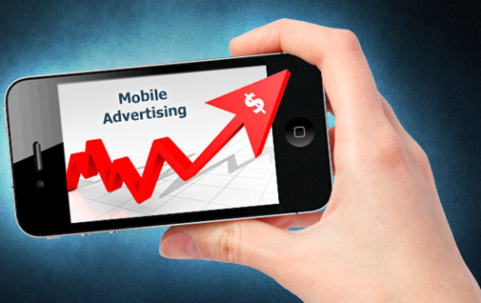
BIA/Kelsey predicts advertisers will spend a total of $139.4 billion on local advertising in 2015. By 2019, total mobile spend by local advertisers will grow to $6.5 billion or about 36% of the total spend in mobile targeting local audiences. BIA/Kelsey predicts advertisers will spend a total of $139.4 billion on local advertising in 2015.
MediaPost 10.9.15
http://www.mediapost.com/publications/article/260110/mobile-spend-by-local-advertisers-forecast-to-hit.html

