Local Community Takes Over Vt. College Radio Station
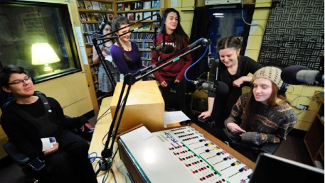
Goddard College in Plainfield, Vt., has gifted its WGDR/WGDH radio station to the nonprofit Central Vermont Community Radio, making the station the state's only community-owned and operated full- power station. CVCR plans to uphold the station's mission of providing a forum for social issues and will maintain its affiliation with the Pacifica Network independent radio community.
Radio World 6/1/21
https://www.radioworld.com/news-and-business/business-and-law/vermont-station-celebrates-transition-to-public-ownership?utm_source=SmartBrief&utm_medium=email&utm_campaign=45863C53-9E40-4489-97A3-CC1A29EF491D&utm_content=6FFFAAEA-C694-4EF2-949E-6ED63618EF8A&utm_term=a25693a1-51b6-4112-bde4-56bd420e983f
Image credit:
https://www.radioworld.com/wp-content/uploads/2021/06/WGDR-WGDH-725.jpg

