Magazine Censored for Covering Henry Ford’s Anti-Semitic Newspaper
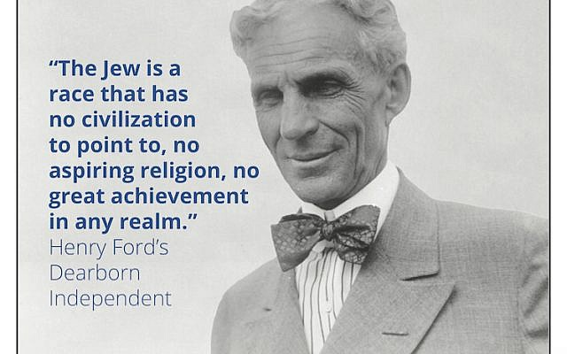
“100 Years Later, Dearborn Confronts the Hate of Hometown Hero Henry Ford” was slated as the cover story of The Dearborn Historian, a quarterly published by a historical commission appointed by the mayor. But before it could reach readers, Dearborn’s mayor censored the magazine and then fired the editor.
Columbia Journalism Review 2/4/19
https://www.cjr.org/united_states_project/dearborn-historian-independent-henry-ford.php
Image credit:
https://static.timesofisrael.com/jewishwdev/uploads/2019/02/dearborn-historian-640x400.jpg

