Majority of Americans Think Cable TV Has Become "Unaffordable"
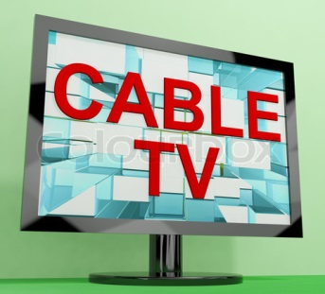
A whopping 90 percent of Americans say that the most important factor when deciding to subscribe to a TV or streaming service is cost. Meanwhile, 56 percent say cable is "unaffordable" and 47 percent say the same about satellite, while just 17 percent deem streaming unaffordable. “People are just homing in on affordability, especially younger consumers,” says Morning Consult VP Tyler Sinclair.
The Hollywood Reporter 10.30.18
https://www.hollywoodreporter.com/news/majority-americans-think-cable-tv-is-unaffordable-1155999?utm_source=API+Need+to+Know+newsletter&utm_campaign=67ab8e8e8c-EMAIL_CAMPAIGN_2018_10_31_11_52&utm_medium=email&utm_term=0_e3bf78af04-67ab8e8e8c-31697553

