Majority Of Broadband Homes Have Smart TV Sets
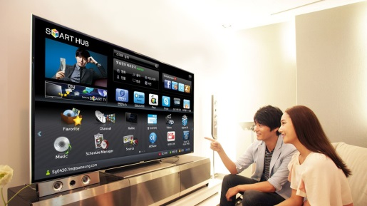
Smart TV sets have reached 55% of broadband-equipped households in the US and are becoming streaming subscribers' default way of accessing content, Parks Associates reports, as viewing on one platform grows in popularity. The company also notes that most people maintain subscriptions on a few central services, then pick up and drop others depending on the programming they want to see.
MediaPost Communications (free registration) 2/11/22
https://www.mediaplaynews.com/parks-55-percent-of-broadband-homes-own-a-smart-tv/
Image credit:
https://cdn.technadu.com/wp-content/uploads/2019/02/Samsung-Smart-TVs-To-Come-Pre-Loaded-with-McAfee-Security.jpg

