Malvertising and Ad Blocking Are Costing $8.2 Billion a Year, IAB Says
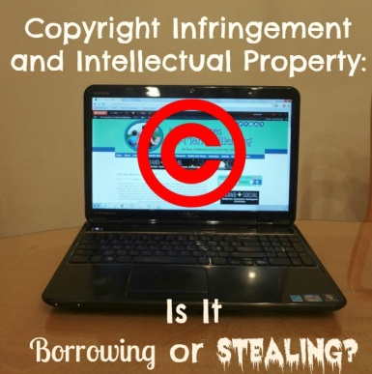
"Infringed content" -- which includes stolen video programming, music and editorial content -- takes another $2.4 billion bite out of the ad ecosystem. Infringed content is primarily made up of pirated music, movies and TV shows posted on sites like Kick Ass Torrents or The Pirate Bay.
Advertising Age 12.1.15
http://adage.com/article/digital/iab-puts-8-2-billion-price-tag-ad-fraud-report/301545/

