Manipulated Images and Video Prey On Confirmation Bias
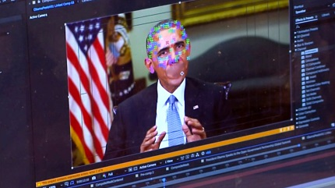
Christye Sisson is part of a U.S. government project that is developing ways to detect images and video that have been manipulated. In the end, writes Sisson, “We’ve found that a key element of the battle between truth and propaganda has nothing to do with technology. It has to do with how people are much more likely to accept something if it confirms their beliefs.”
Nieman Lab 9.10.19
https://www.niemanlab.org/2019/09/i-create-convincing-manipulated-images-and-videos-but-quality-may-not-matter-much/?utm_source=API+Need+to+Know+newsletter&utm_campaign=da68fa96aa-EMAIL_CAMPAIGN_2019_09_11_12_28&utm_medium=email&utm_term=0_e3bf78af04-da68fa96aa-31697553
Image credit:
https://static01.nyt.com/images/2018/10/17/opinion/17Boylan/17Boylan-videoSixteenByNineJumbo1600.jpg

