March Madness Gains in a Year of Television Declines
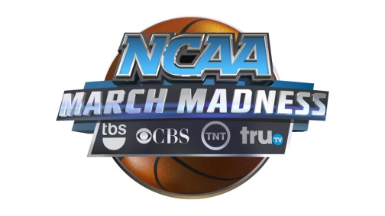
Not only is the men’s NCAA basketball tournament not losing viewers, but it actually put up its best opening-weekend numbers in 24 years. The opening weekend averaged 9.325 million total viewers across CBS, tru TV, TBS and TNT, according to Nielsen, up 10 percent from last year, when it averaged 8.5 million.
MediaLife 3.21.17
http://www.medialifemagazine.com/march-madness-gains-year-sports-declines/

