Marketers Look To Gaming, Esports As Next Frontier
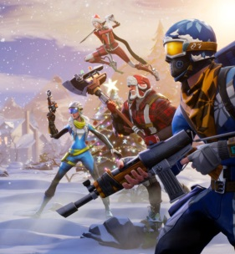
Events such as IAB PlayFronts and moves such as NBCUniversal's partnership with Anzu point to the rising desire among brands to finely tune gaming and esports efforts, writes Peter Adams. "If you look at the collection of marketers that are entering the space ... there's no question that it's broader, more diverse and representative of the larger advertising market than I think at any point prior to this," says David Eichenstein of 4D Sight, a video monetization platform focused on gaming.
Marketing Dive 3.7.22
https://www.marketingdive.com/news/can-marketers-crack-the-code-on-gaming-as-audiences-diversify/619929/
Image credit:
https://one37pm.imgix.net/one37pm-editor-dev-images/s3fs-public/user-images/2018-11/Epic-Games-Mobile.jpg?ch=Width,DPR&auto=compress&q=60&w=1&fit=clip&dpr=2

