Marketers Must Start Tackling "Dark Social"
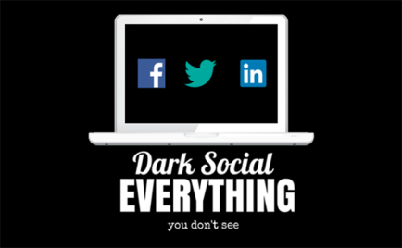
Marketers face a huge opportunity to engage with consumers and to track social content sharing through often-overlooked "dark social" -- private messaging that transpires through emails or chat apps, Joao Romao writes. "With the number of users of messaging apps only going to grow, it will become the norm for individuals and consumers to share links to articles or products in private messages, rather than in public posts on social network," he writes.
MarTech Advisor 9/10/18
https://www.martechadvisor.com/articles/social-media-marketing-2/why-its-time-to-shine-the-light-on-dark-social/
Image credit:
https://www.iim.fr/ecole-web/wp-content/uploads/2015/02/DarkSocialHeader-dont-seepng.png

