Marketers Need to Adapt to Mobile Entertainment Preferences
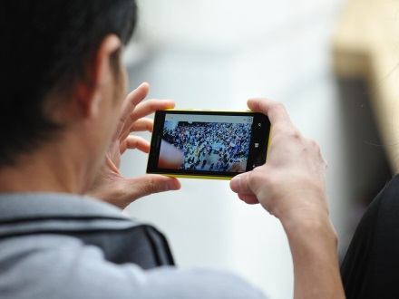
Mobile devices are expected to surpass TV as the preferred method for consuming media, which means more advertisers will look to digital to broaden their reach and boost revenues, writes Amy Gesenhues. She recommends advertisers make sure they're investing in video ads and paying attention to their return-on-investment for TV promotions, which could well be diminishing.
Marketing Land 4/15/19
https://marketingland.com/more-people-will-turn-to-their-mobile-device-instead-of-tv-for-entertainment-in-2019-259522
Image credit:
https://www.blogdelfotografo.com/wp-content/uploads/2013/11/fotografia-movil.jpg

