Marketers Racing To Reach Voice Audiences
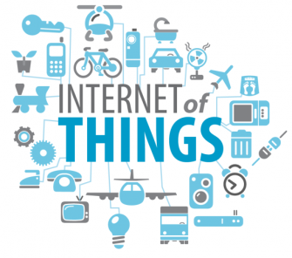
As brands increasingly seek to understand the Internet of Things, marketers are keying in on how Amazon and Google will dominate connected devices in 2018. That’s why Amazon’s Alexa and the Google Home — with their rapidly expanding sets of AI skills and services — will be completely unavoidable for the 180,000 expected attendees at this week’s annual CES in Las Vegas.
Adweek 11.9.17
www.adweek.com/digital/marketers-are-racing-to-reach-rapidly-growing-audiences-on-amazons-alexa-and-google-home/
Image credit:
https://www.bing.com/images/search?view=detailV2&ccid=O%2fxtNuxd&id=C874A6CFA746FBA18BB5BA939CA17AD4EE1CC241&thid=OIP.O_xtNuxdATXY4YPncOCH6gHaEl&mediaurl=http%3a%2f%2fblog.agroknow.com%2fwp-content%2fuploads%2f2015%2f09%2fInternet-Of-Things-825x510.png&exph=510&expw=825&q=internet+of+things&simid=608031465485829522&selectedIndex=2&ajaxhist=0

