Marketers Should Pay Attention to These 2021 Trends
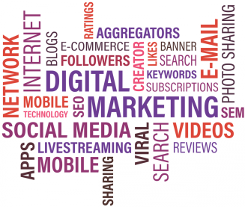
This article sets out eight marketing trends to watch in 2021. These include increased competition in digital media, continued importance of influencer marketing, the need to customize creative for each social platform to resonate with different audiences and the need for brands to authentically support social activism.
Marketing Dive 1.4.21
https://www.marketingdive.com/news/8-trends-set-to-reshape-marketing-in-2021/592658/
Image credit:
https://digitalbloggers.com/assets/media/images/64gz_bigthumb_Digital-Marketing-Trends-2017-5.png

