Marriott Drives Awareness with Mixed Campaign
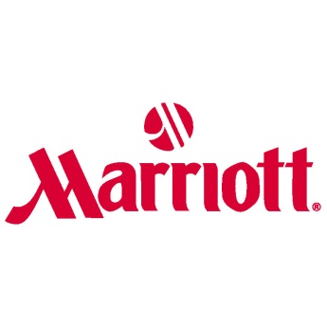
Marriott is focusing on building brand awareness with its "Go Beyond" campaign, which uses television, digital and traditional advertising in a mixed marketing campaign. Marriott's Mara Hannula said, "Customers will recognize your brand more than if you just push ads out without paying mind to where they're appearing."
AdExchanger.com 4/7/17
https://adexchanger.com/advertiser/marriott-integrated-marketing-exercise-motion/

