Media Downplay Climate Disruption’s Ever-Growing Role in Driving Migration
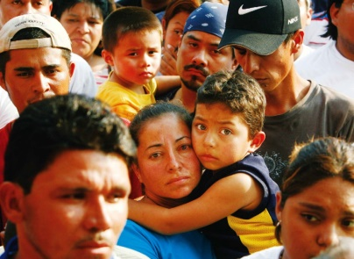
It would be easy for even a diligent news consumer to not know that climate change is one of the central factors driving refugees to cross the border, since it’s usually not mentioned at all in most alarmist reports about the so-called “border crisis” In fact, although a few good articles have been dedicated to making the connection it’s usually absent even among reports purporting to explain why people are making the dangerous journey.
FAIR 7.30.19
https://fair.org/home/media-downplay-climate-disruptions-ever-growing-role-in-driving-migration/?awt_l=OonDO&awt_m=gb0AYn5zcmOI_TQ
Image credit:
http://njfon.org/vahq/wp-content/uploads/2015/08/latino-immigrants-labeled-for-reuse.jpg

