Media Executives Examine The Future Of Television
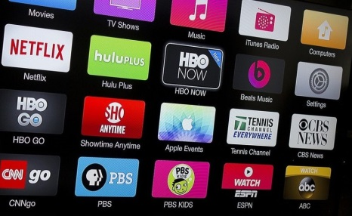
The rise of on-demand video streaming will continue to affect linear television, media executives predict, although opinions on the medium's future are mixed. Executives say Netflix and Amazon Prime are the two streaming services most likely to stick around, and mergers and acquisitions of smaller streamers are likely.
CNBC 2/7/23
https://www.cnbc.com/2023/02/07/future-of-tv-predictions.html
Image credit:
https://www.techolac.com/wp-content/uploads/2020/01/streaming-tv-channels.jpg

