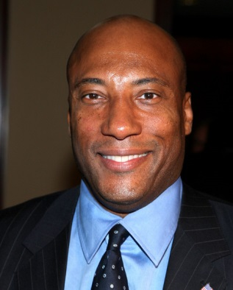
Media Mogul Allen Picks Up 11 Stations
Former NBC's "Real People" star Byron Allen has finalized a $290 million deal with USA Television that will see Allen take ownership of 11 more broadcast stations across the country. The deal is awaiting approval from the Federal Communications Commission.
Radio and Television Business Report 10/1/19
https://www.rbr.com/byron-allen-grabs-bob-prathers-eleven-broadcast-tv-stations/
Image credit:
https://northdallasgazette.com/wp-content/uploads/2016/01/Byron-Allen.jpg

