Mental Health Drives Reduced Instagram Use
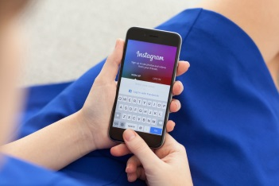
Some 38% of US Instagram users have cut down the amount of time they spend on the platform for mental health reasons, while 38% have blocked accounts, 21% have set limits on screen time and 18% have deleted the app, according to Opinium research. In addition, 50% think influencer marketing will be a permanent strategy and 21% have purchased products recommended by influencers.
MediaPost Communications (free registration) 1/24/22
https://www.mediapost.com/publications/article/370552/americans-cutting-back-on-instagram-use-to-improve.html
Image credit:
https://www.smallbusinessbonfire.com/wp-content/uploads/2017/09/instagram-stories-promote-business.jpg

