Messi’s Twitch Interview Shows How Social Media Is Conquering Sport
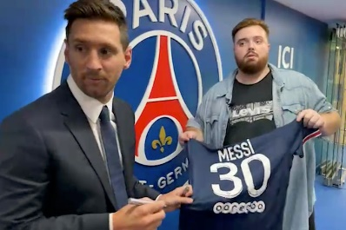
Spanish influencer Ibai Llanos chatted with Lionel Messi on Amazon.com Inc.’s streaming platform Twitch after the world’s best-paid athlete signed with French soccer club Paris Saint Germain from Barcelona. More than 317,000 people watched the exclusive interview, the kind of prestigious content that would often be sold to the highest bidder for TV broadcast in different territories.
Bloomberg 8.11.21
https://www.bloomberg.com/news/articles/2021-08-11/messi-on-twitch-shows-how-social-media-are-conquering-sport
Image credit:
https://s3-prod.adage.com/s3fs-public/styles/width_1024/public/20210811_messi_ibai_twitch_3x2.jpg

