Nielsen: More Millennials Turn to TV News During Big Events
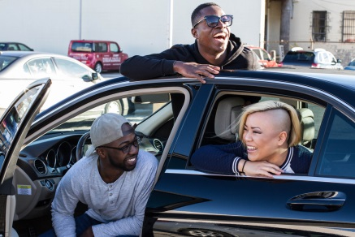
Digital sources are typically the go-to for news among millennials, but a Nielsen study shows that TV news viewership rises across the demographic during big events. Just 8% of millennials get their news from TV alone, but big events, such as a presidential inauguration, nearly double the reach of TV news in the group.
Broadcasting & Cable 9/10/18
https://www.broadcastingcable.com/news/nielsen-big-events-drive-millennials-to-tv-news
Image credit:
https://www.flickr.com/photos/sabrinafvholder/32547488444/

