Millennials and The Big Shift in TV Habits
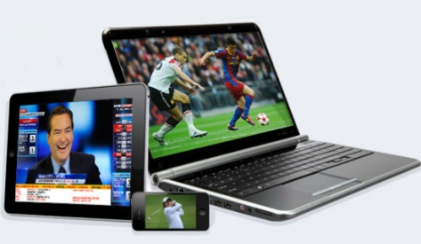
A study finds that across all demographics there was a big move in 2014 away from what it calls appointment TV viewing, or watching shows on traditional television, and toward binge-viewing programs on viewers’ own schedule, whether via DVRs or a subscription video on demand site such as Netflix. Trailing Millennials spend 41 percent of their time watching TV shows on a laptop or PC; nearly as much time as they spend watching on a TV set (43 percent).
MediaLife 6.4.15

http://www.medialifemagazine.com/behind-the-big-shift-in-tv-habits/

