Misinformation Has Created a New World Disorder
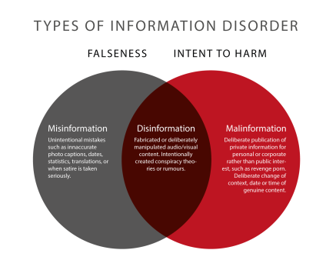
“Bad actors who want to deepen existing tensions [design] content that they hope will so anger or excite targeted users that the audience will become the messenger. The goal is that users will use their own social capital to reinforce and give credibility to that original message. Most of this content is designed not to persuade people in any particular direction but to cause confusion, to overwhelm, and to undermine trust in democratic institutions from the electoral system to journalism.”
Scientific American 9.1.19
https://www.scientificamerican.com/article/misinformation-has-created-a-new-world-disorder/
Image credit:
https://firstdraftnews.org/wp-content/uploads/2018/07/Types-of-Information-Disorder-Venn-Diagram.png

