MLB Brings Baseball To Twitch, Minecraft
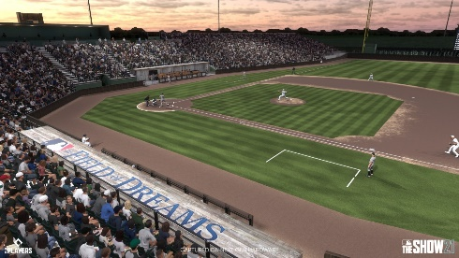
MLB hosted a Twitch watch party for Thursday's New York Yankees vs. Chicago White Sox game at Iowa's Field of Dreams. The league also signed a multiyear deal with Minecraft, which enables fans to play Home Run Derby in all 30 league ballparks in the game and buy their characters MLB team jerseys.
Adweek 8/12/21
https://www.adweek.com/social-marketing/mlb-goes-the-distance-with-field-of-dreams-game-initiatives-on-twitch-minecraft/
Image credit:
https://www.gameinformer.com/sites/default/files/styles/full/public/2021/08/09/356c13ba/mlb_the_show_21_field_of_dreams_2.jpg

