MLB In Talks To Launch Nationwide Streaming Service
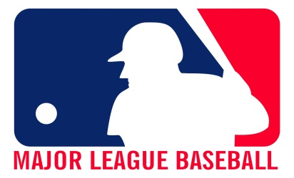
The web-based service — which could address a decades-old annoyance for baseball fans that some have partly blamed for the league’s steadily declining viewership — could launch as early as the 2023 season, a person with direct knowledge of the negotiations said.
New York Post 10.17.21
https://nypost.com/2021/10/17/mlb-in-talks-to-launch-nationwide-streaming-service-for-home-games/?utm_source=Listrak&utm_medium=Email&utm_term=MLB+In+Talks+To+Launch+Nationwide+Streaming+Service+For+Home+Games&utm_campaign=MLB+In+Talks+To+Launch+Nationwide+Streaming+Service

