Mobile Gaming Increases Share Of Gaming Market
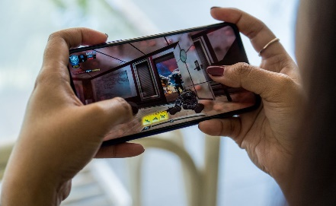
Mobile gaming grew to 52% of the gaming market, despite predictions it would shrink, according to Newzoo data. "This shows that the games market is definitely no longer the seasonal, hit-driven business it once was. New gaming content no longer means new games or new hardware -- a new season pass is just as likely to drive revenues," says Tom Wijman of Newzoo.
VentureBeat 12/22/21
https://venturebeat.com/2021/12/22/newzoo-mobile-gaming-accounts-for-the-largest-part-of-the-2021-market/
Image credit:
https://blog.grosvenorcasinos.com/wp-content/uploads/2020/10/H1.jpg

