Mobile Grows For Cable Companies
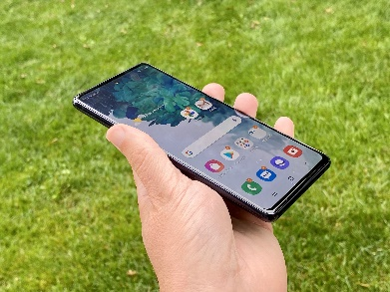
Comcast's mobile service gained 310,000 accounts during last year's fourth quarter, and CEO Dave Watson says the market has plenty of room for growth. Charter Communications reached 7.8 million total lines after its 546,000 quarterly growth.
Fierce Wireless 2/4/24
https://www.fiercewireless.com/wireless/comcast-charter-add-subs-survey-finds-consumers-very-open-mvnos
Image copyright:
https://cdn.mos.cms.futurecdn.net/u6ACPLnZhHS9fmJGE772nU.jpg

