Mobile Now Makes up More than Half of Digital Ad Spend
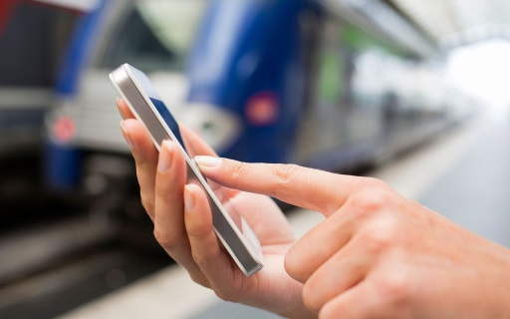
Spending on mobile advertising accounted for 51% of the $72.5 billion allocated to US digital advertising last year, the first time mobile has passed the halfway mark, per the IAB Internet Advertising Revenue Report. Mobile ad investment spiked 77% to hit $36.6 billion in 2016, compared with $20.7 billion in 2015.
AdExchanger.com 4.26.17
https://adexchanger.com/digital-audio-radio/mobile-dominates-digital-growth-iab-nods-digital-audio-revenues-surge/

