Mobile Usage, Advertising Surge Amid Pandemic
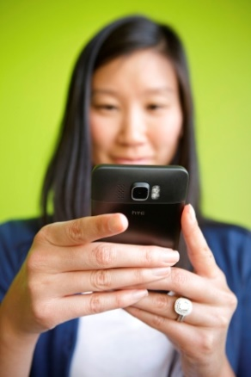
App Annie reports that individuals increased daily mobile device usage by 20% during the first half of the year, compared with 2019, for a total 1.6 trillion hours, while brands followed suit by increasing mobile ads by 70%. App Annie's Lexi Sydow said the pandemic spurred mobile usage by two to three years and predicts "businesses who prioritize mobile will outpace competitors, as mobile represents a significant driver of revenue growth for businesses."
VentureBeat 8.17.20
https://venturebeat.com/2020/08/17/app-annie-why-mobile-advertising-is-a-must-during-the-pandemic/
Image credit:
https://upperlakesfoods.com/wp-content/uploads/2014/06/Person-using-phone.jpg

