Mobile Usage is Even Bigger Than You Think
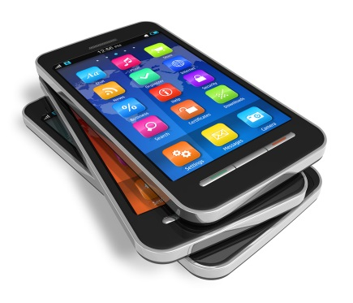
A new report from comScore, which examines cross-platform media consumption, finds that smartphone usage has not simply grown over the past three years. It’s actually doubled. The study found the average person spends two hours and 51 minutes a day on mobile. Per month, that translates into more than a trillion minutes of smartphone usage across America.
MediaLife 3.23.17
http://www.medialifemagazine.com/surprise-mobile-usage-even-bigger-think/
Image source:
https://www.hostinganddesigns.com/WPDesigns2/wp-content/uploads/2012/10/bigstock-Set-of-touchscreen-smartphones-23947325.jpg

