Mobile, Social Users Consume Content More Quickly
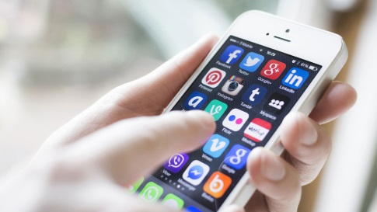
Research reveals that people consume and understand content faster on mobile devices and on social networks than through other media. This is especially pertinent for video content, in which the first few seconds are crucial to capturing attention and engaging viewers.
Advertising Age 2/1/16
http://adage.com/article/digitalnext/facebook-twitter-mobile-content-consumed-differently/302397/

