Mobile Video Ad Spending Growing
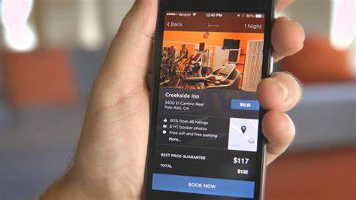
This year, US advertisers will spend two-thirds of their digital budgets on mobile placements. Mobile ad spending has taken the majority of digital spending every year since 2015 and both search and display spending skew heavily mobile. But even though it falls under the display umbrella, video is the only digital ad format where more ad dollars are spent outside mobile channels.
eMarketer 4.8.19
https://www.emarketer.com/content/breaking-down-us-digital-video-ad-spending?ecid=NL1001
Image credit:
https://i.ytimg.com/vi/c_mQftkC_Tc/maxresdefault.jpg

