MOEy Finalists for Best Student Journalism Announced
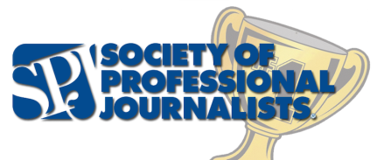
The Society of Professional Journalists is giving a national award for the year’s best student journalism. The MOEy best in show award is selected from more than 4,100 entries in SPJ's 2015 Mark of Excellence Awards competition. Student entries are first judged regionally in print, radio, television and online collegiate journalism categories. First-place regional winners advance to the national competition and then are able to compete for the MOEy award.
Society of Professional Journalists 8.16.16
http://www.spj.org/news.asp?ref=1462

