Nearly 60% of Americans Now Stream Video Daily on Smart Phones, Tablets and Computers
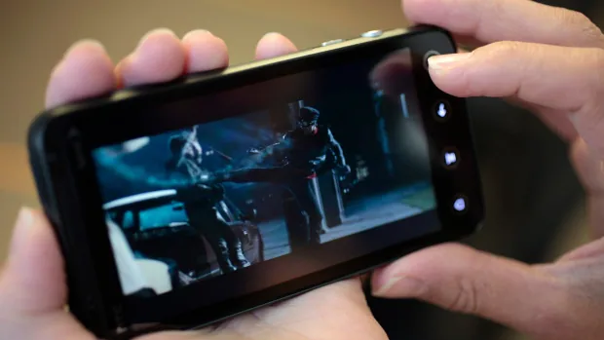
Yup, Quibi and Go90 were actually onto something. The latest Leichtman Research Group data reveals a huge recent uptick in mobile consumption.
TV Tech 8.24.22
https://www.tvtechnology.com/news/more-adults-watching-video-on-non-tv-devices?utm_source=SmartBrief&utm_medium=email&utm_campaign=C74FC4FA-5D4D-4151-8915-3043BA411DBE&utm_content=BA8D012C-D76E-4C12-BE63-473AF7627ACA&utm_term=a25693a1-51b6-4112-bde4-56bd420e983f
Image credit:
https://i.cbc.ca/1.2729990.1407418475!/cpImage/httpImage/image.jpg_gen/derivatives/16x9_620/smartphone-movie-video.jpg

