More Than 100 Million Americans Will Use Proximity Mobile Payments In 2021
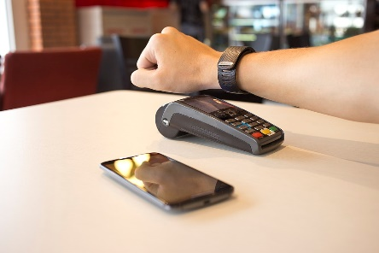
“Contactless payment is not just taking the form of traditional credit and debit cards waved in front of a payment terminal, but more so from mobile wallets like Apple Pay, Google Pay, and retailers’ mobile apps,” said Oscar Orozco, eMarketer director of forecasting at Insider Intelligence.
eMarketer 5.5.21
https://www.emarketer.com/content/more-than-100-million-americans-will-use-proximity-mobile-payments-2021?ecid=NL1014
Image credit:
https://www.telemediaonline.co.uk/wp-content/uploads/2018/03/1200px-PAY.jpg

